**Test Module**

* Test Pool :

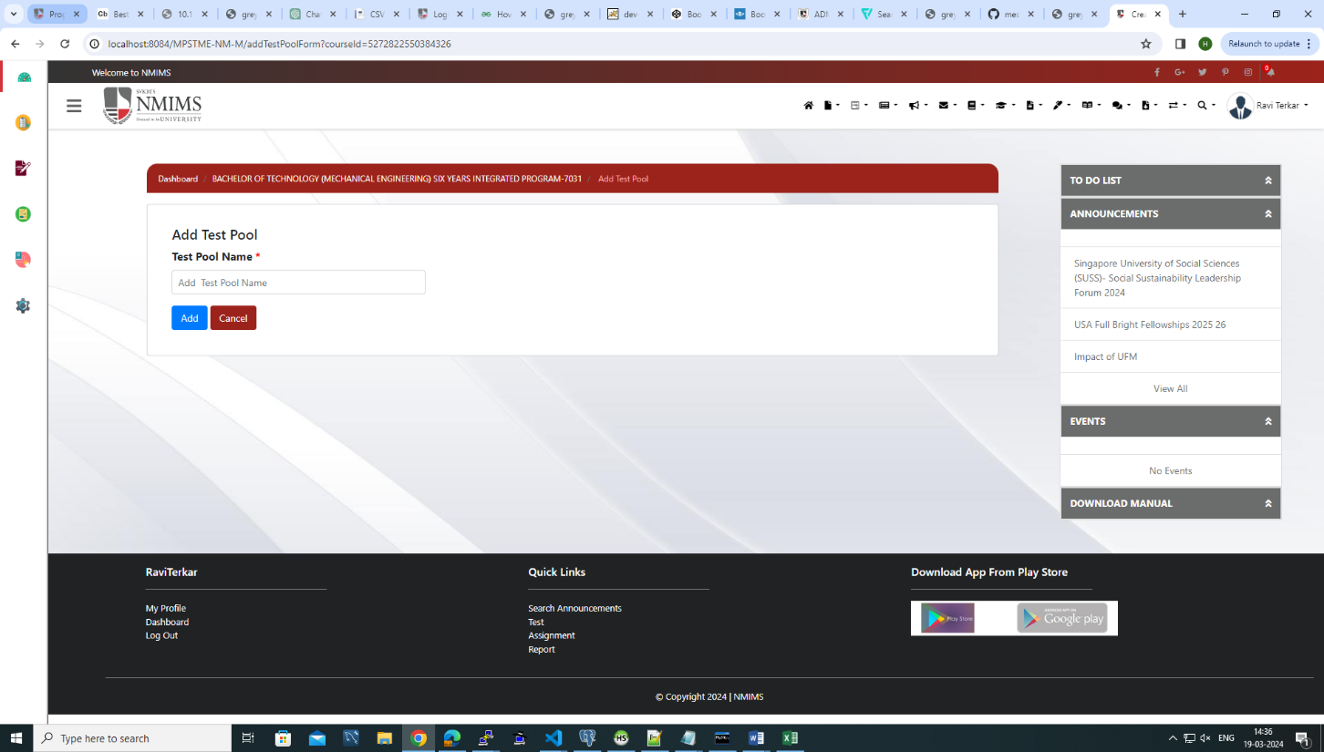

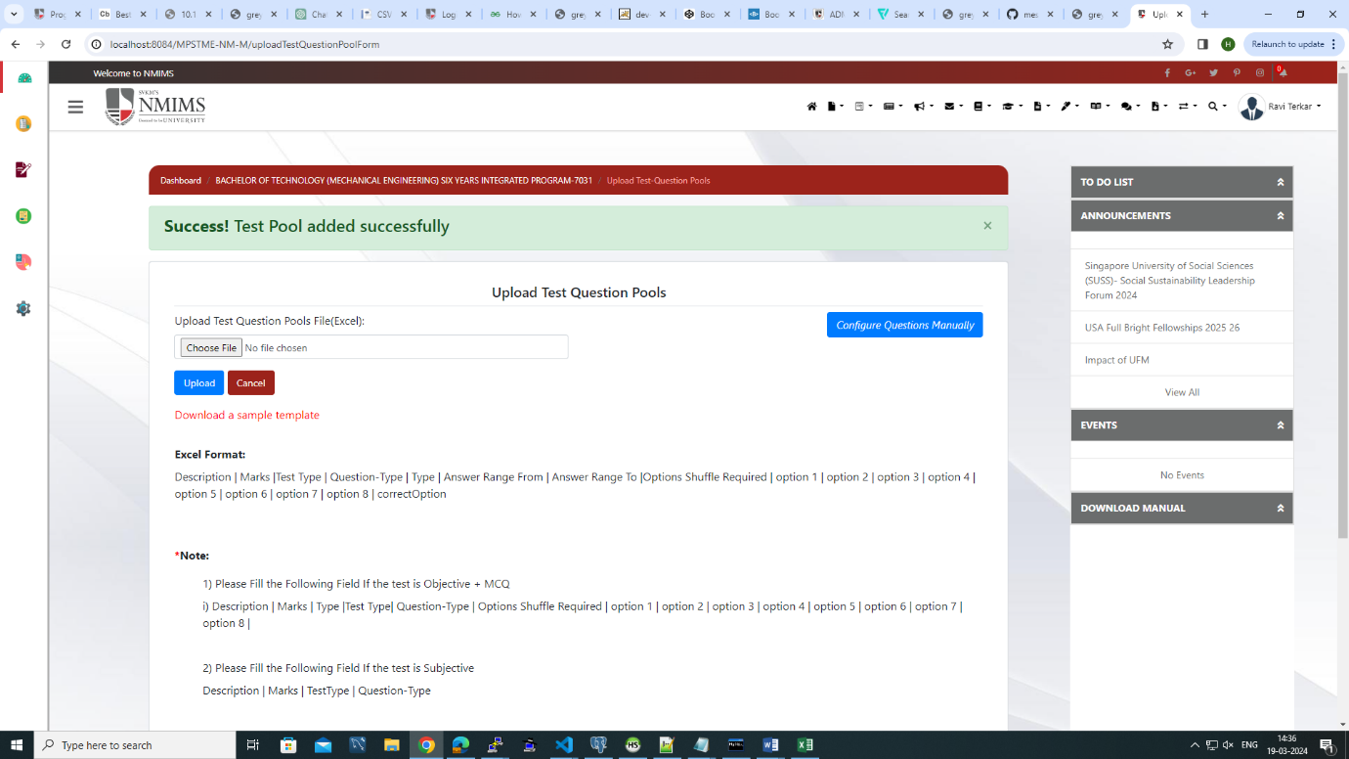

In Test Pool we create a pool where multiple questions are configured together. In Test Pool, we can create any type of questions such as Objective, Subjective or of Mixed type. We can configure questions by two ways by manually or via excel.

Test Pool Requirements :-

1. Question Upload Via Excel

* Can upload objective type of questions with only four options according to the structure provided
* Create Test :

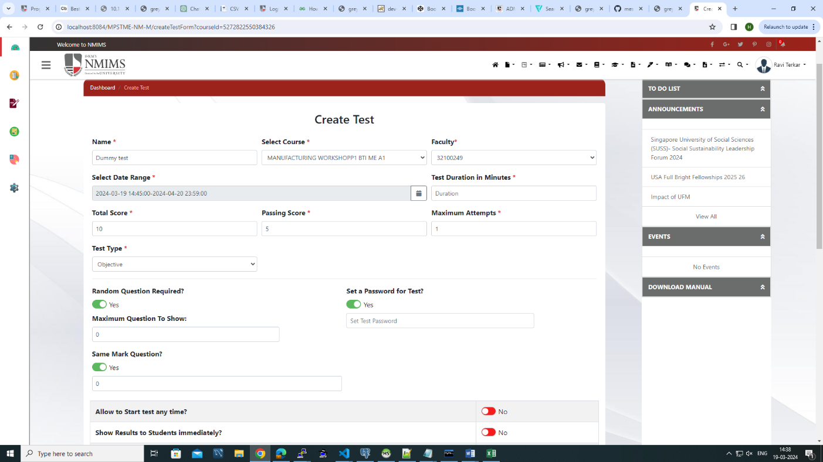

To create test, faculty have to fill the required test details such as test name, test start time and end time, total marks, passing marks and duration time of test and type for test like Objective, Subjective or Mixed Type.

* Test Details :

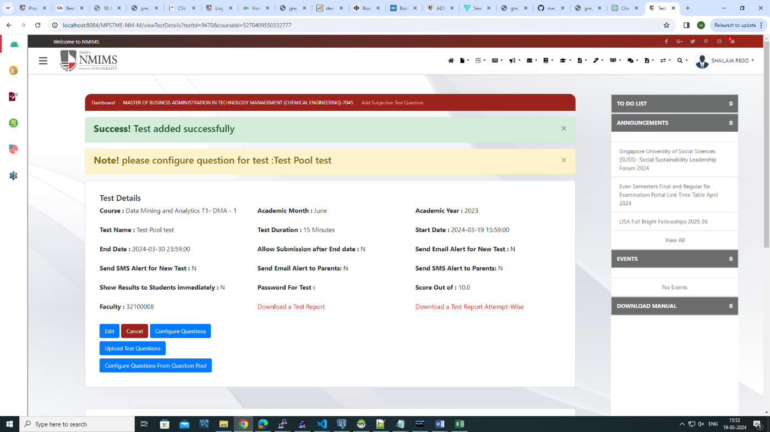

After creating Test, faculties have to configure questions for the test, faculties can configure questions by manually or via uploading excel. Questions can also be configured from test pools. Faculties can also edit, the test by clicking on edit button.

* Upload Questions Manually :

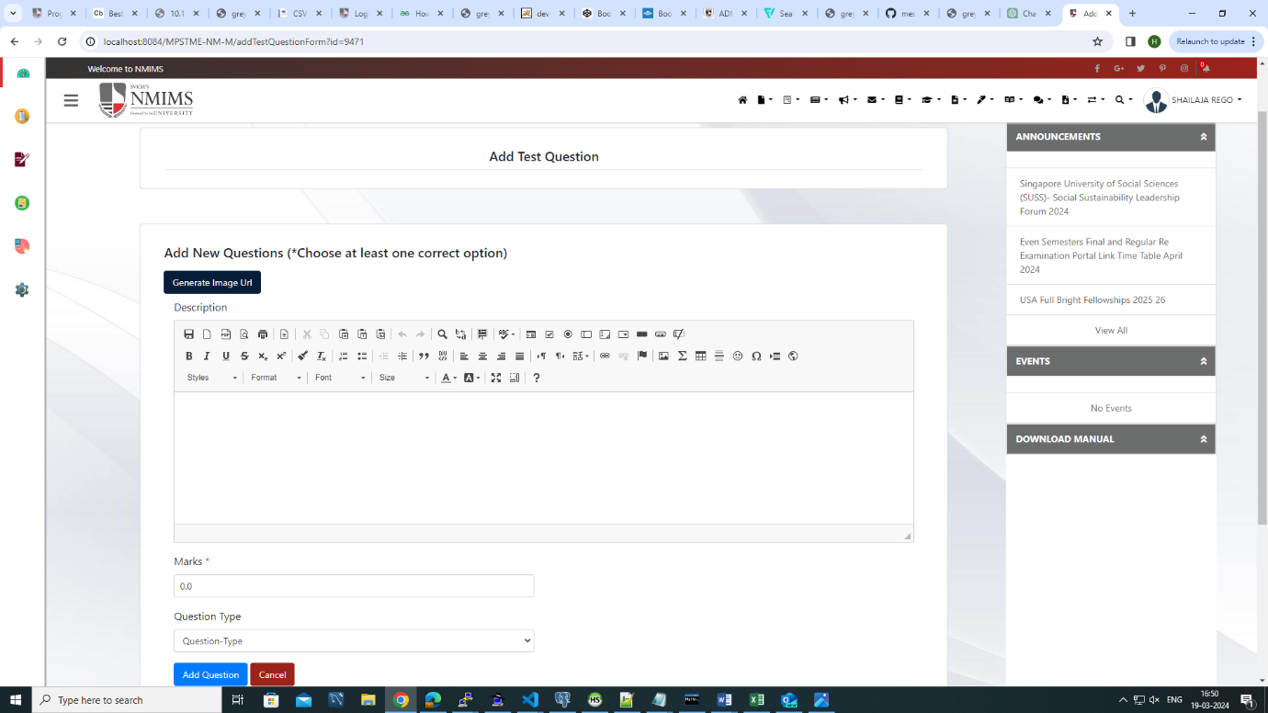

In this faculties can create questions by adding test description, question type based on selected test type and selecting marks for questions , faculty can also upload image question by upload image by clicking on generate image url button.

* Upload Questions Via Excel

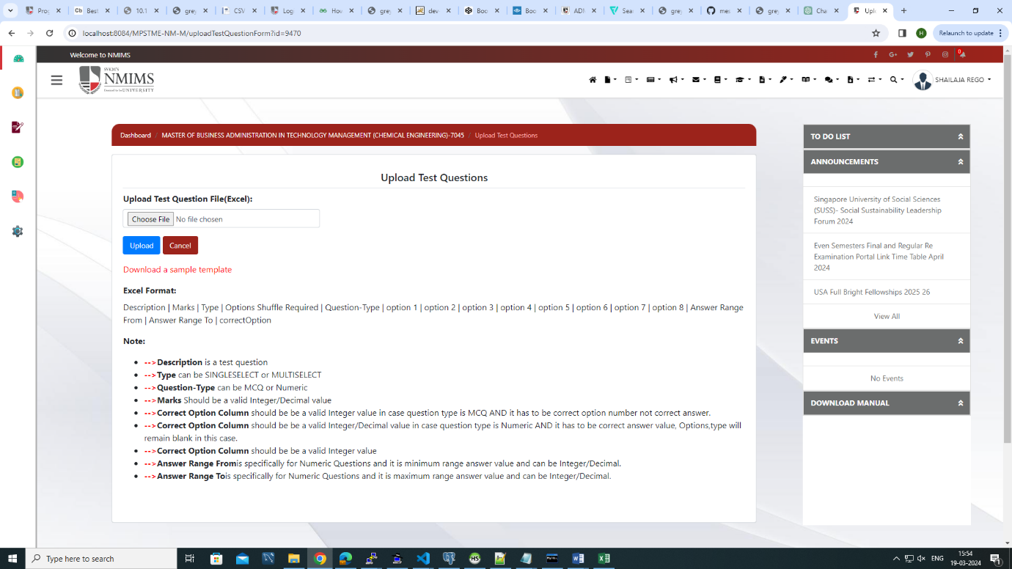

Faculties need to download a sample template, fill all required details same as in manually option to upload questions.

* Configure Questions From Pool

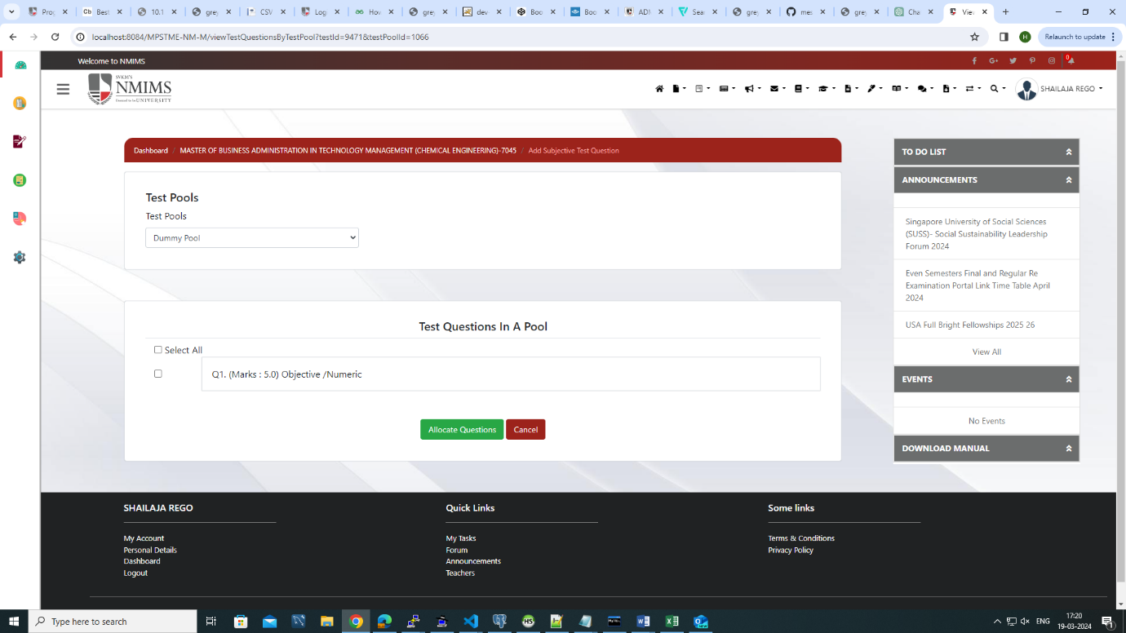

To configure questions from pool, faculty have to select test pool from dropdown. After selecting the pool, the questions will appear from that pool which has been created, faculty have to select questions which they want and click on allocate questions button, they can also select all questions from pool by selecting the option ‘Select All’. By clicking on ‘Allocate Questions’, the questions will be configured for the created test.

* Allocate Students For Test:

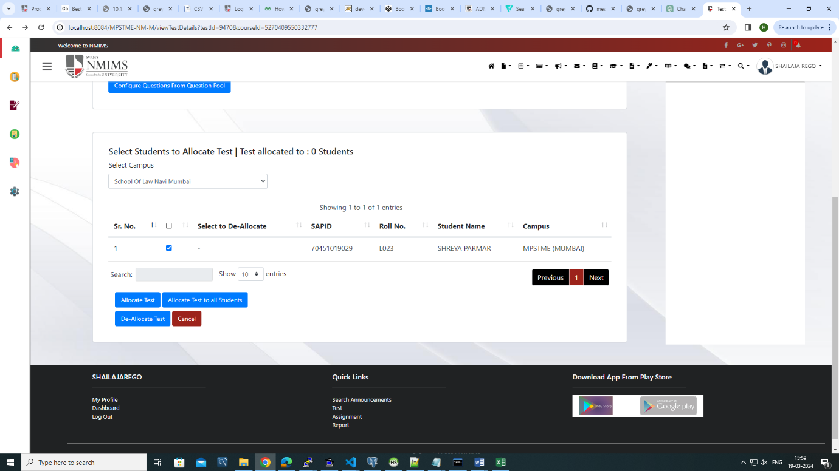

After configuring questions for the test, ‘Proceed To Allocate Students’ option gets enabled. Then

Faculty have to select students to allocate the created test. If faculty wants to allocate test to selected students then they have to select the particular students and click on ‘Allocate Test’ option, if faculty wants to allocate test to all students then they have to select the checkbox from table header through which all students will be selected and the click on ‘Allocate Test To All Students’.